Atchaya R

727721euai009

1.

package com.example.demo.sampletesting;

import org.openqa.selenium.By;

import org.openqa.selenium.WebDriver;

import org.openqa.selenium.edge.EdgeDriver;

import org.testng.Assert;

import io.github.bonigarcia.wdm.WebDriverManager;

/**

* Hello world!

*

*/

public class NewTest2

{

public static void main( String[] args ) throws InterruptedException

{

WebDriverManager.edgedriver().setup();

WebDriver driver=new EdgeDriver();

driver.get("https://www.saucedemo.com");

driver.findElement(By.xpath("//*[@id=\"user-name\"]")).sendKeys("standard_user");

driver.findElement(By.xpath("//*[@id=\"password\"]")).sendKeys("secret_sauce");

Thread.sleep(1000);

driver.findElement(By.xpath("//*[@id=\"login-button\"]")).click();

driver.findElement(By.xpath("//*[@id=\"add-to-cart-sauce-labs-backpack\"]")).click();

driver.findElement(By.xpath("//*[@id=\"shopping_cart_container\"]/a")).click();

driver.findElement(By.xpath("//*[@id=\"checkout\"]")).click();

Thread.sleep(1000);

driver.findElement(By.xpath("//*[@id=\"first-name\"]")).sendKeys("Atchaya");

driver.findElement(By.xpath("//*[@id=\"last-name\"]")).sendKeys("Raja");

driver.findElement(By.xpath("//*[@id=\"postal-code\"]")).sendKeys("622003");

Thread.sleep(1000);

driver.findElement(By.xpath("//*[@id=\"continue\"]")).click();

System.out.println("Name of the product: " + driver.findElement(By.xpath("/html/body/div/div/div/div[2]/div/div[1]/div[3]/div[2]/a/div")).getText());

System.out.println("Price of the product: " + driver.findElement(By.xpath("/html/body/div/div/div/div[2]/div/div[1]/div[3]/div[2]/div[2]/div")).getText());

String title=driver.getTitle();

String tile="Swag Labs";

String url=driver.getCurrentUrl();

String ourl="https://www.saucedemo.com/checkout-step-two.html";

if(url.equals(ourl))

{

System.out.println("true");

}

if(title.equals(tile))

{

System.out.print("true");

}

}

}

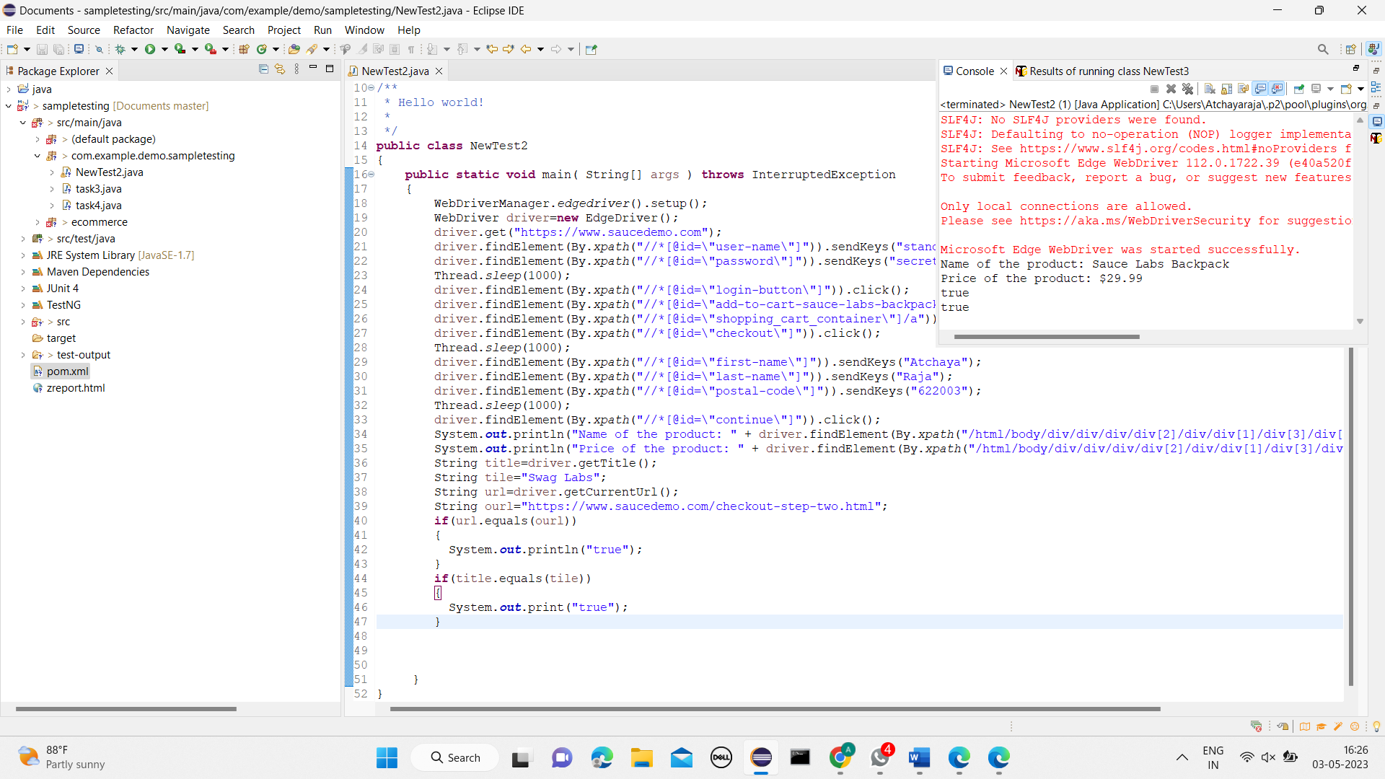

2.

package com.example.thursday.selproj2;

import org.openqa.selenium.By;

import org.openqa.selenium.WebDriver;

import org.openqa.selenium.edge.EdgeDriver;

import io.github.bonigarcia.wdm.WebDriverManager;

public class task3 {

public static void main(String[] args) throws InterruptedException {

WebDriverManager.edgedriver().setup();

WebDriver driver = new EdgeDriver();

driver.get ("https://www.saucedemo.com/");

driver.manage().window().maximize() ;

driver.findElement(By.xpath("//*[@id=\"user-name\"]")).sendKeys("standard_user");

driver.findElement(By.xpath("//*[@id=\"password\"]")).sendKeys("secret_sauce");

driver.findElement(By.xpath("//*[@id=\"login-button\"]")).click();

String firsttext=driver.findElement(By.xpath("//*[@id=\"item_4_title_link\"]/div")).getText();

System.out.println(firsttext);

driver.findElement(By.xpath("//*[@id=\"header_container\"]/div[2]/div/span/select")).click();

driver.findElement(By.xpath("//*[@id=\"header_container\"]/div[2]/div/span/select/option[2]")).click();

String secondtext=driver.findElement(By.xpath("//*[@id=\"item_3_title_link\"]/div")).getText();

System.out.println(secondtext);

System.out.println("Filter (A-Z and Z-A) applied successfully");

driver.findElement(By.xpath("//*[@id=\"header_container\"]/div[2]/div/span/select")).click();

driver.findElement(By.xpath("//*[@id=\"header_container\"]/div[2]/div/span/select/option[3]")).click();

String thirdtext=driver.findElement(By.xpath("//*[@id=\"inventory_container\"]/div/div[1]/div[2]/div[2]/div")).getText();

System.out.println(thirdtext);

driver.findElement(By.xpath("//*[@id=\"header_container\"]/div[2]/div/span/select")).click();

driver.findElement(By.xpath("//*[@id=\"header_container\"]/div[2]/div/span/select/option[4]")).click();

String fourthtext=driver.findElement(By.xpath("//*[@id=\"inventory_container\"]/div/div[1]/div[2]/div[2]/div")).getText();

System.out.println(fourthtext);

System.out.println("filter (low price- high price and high price - low price ) applied sucessfully");

Thread.sleep(5000);

driver.quit();

}

}

